Some useful constants: m_{electron} = 9.11 × 10⁻³¹ kg, m_{proton} = 1.67 × 10⁻²⁷ kg, magnitude of charge of proton or electron = 1.6 × 10⁻¹⁹ C, k = 9 ×10⁹ Nm²/C²

1. The electron and proton of a hydrogen atom are separated (on the average) by a distance of about 5.3×10⁻¹¹ m. Find the magnitude of the electric force. The charge of a proton is 1.6 × 10⁻¹⁹ C.

2. Three charges lies along the x-axis as shown. The positive charge q₁ = 15 μC is at x = 2.0 m, and the positive charge q₂ = 6.0 μC is at the origin. Where must a negative charge q₃ be placed on the x-axis so that the resultant electric force on it is zero?
+
+
˗
q₂
q₃
q₁
2.0 m
x
2.0 - x

3. Charge q₁ = 7.00 μC is at the origin, and q₂ = -5.00 μC is on the x-axis, 0.300 m from the origin as shown. Find
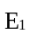
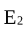
a) the magnitude and direction of the electric field at point P, which has co-ordinates (0, 0.400) m.
+
q₁
0.300 m
q₂
x
P
2.00 μC
0.400 m
0.500 m
˗
ϕ
b) the force on a charge of 2.00×10⁻⁸ C placed at P.

4. In an experiment in space, one proton is held fixed and another proton is released from rest a distance of 2.50 mm away. What is the initial acceleration of the proton after it is released? The mass of a proton is 1.67 × 10⁻²⁷ kg.

5. A proton is travelling horizontally to the right at 4.50 × 10⁶ m/s. (a) Find the magnitude
and direction of the weakest electric field that can bring the proton uniformly to rest
over a distance of 3.20 cm. (b) How much time does it take the proton to stop after
entering the field? (c) What minimum field (magnitude and direction) would be needed
to stop an electron under the conditions of part (a)?

6. A point charge +8.75 µC is glued down on a horizontal frictionless table. It is tied
to a point charge −6.50 µC by a light, nonconducting wire of length 2.50 cm. A uniform electric field of magnitude 1.85×10⁸ N/C is directed parallel to the wire, as shown in the below figure. (a) Find the tension in the wire. (b) What would the tension be if both charges were negative?
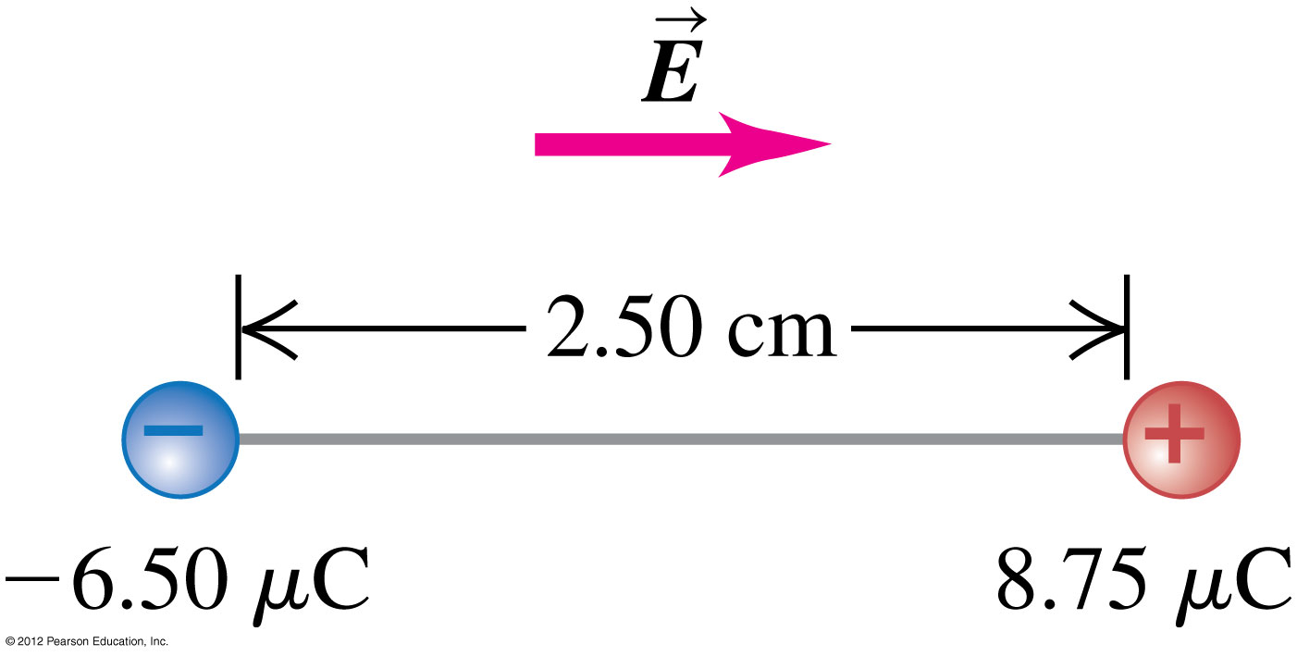

7. A point charge q₁ = −4.00 nC is at the point x = 0.600 m, y = 0.800 m and a second
point charge q₂ = +6.00 nC is at the point x = 0.600 m, y = 0. Calculate the magnitude
and direction of the net electric field at the origin due to these two point charges.

8. A point charge q₁ = +2.40 µC is held stationary at the origin. A second point charge
q₂ = −4.30 µC moves from the point x = 0.150 m, y = 0 to the point x = 0.250 m, y =
0.250 m How much work is done by the electric force on q₂?

9. A point charge q₁ is held stationary at the origin. A second charge q₂ is placed at point a
and the electric potential energy of the pair of charges is +5.4 × 10⁻⁸ J. When the second
charge is moved to point b, the electric force on the charge does –1.9 × 10⁻⁸ J of work.
What is the electric potential energy of the pair of charges when the second charge is at
point b?

10. Point charges q₁ = +2.00 µC and q₂ = −2.00 µC are placed at adjacent corners of a
square for which the length of each side is 3.00 cm. Point a is at the center of the square,
and point b is at the empty corner closest to q₂. Take the electric potential to be zero at a
distance far from both charges. (a) What is the electric potential at point a due to q₁ and
q₂? (b) What is the electric potential at point b? (c) A point charge q₃ = −5.00 µC moves
from point a to point b. How much work is done on q₃ by the electric forces exerted by
q₁ and q₂? Is this work positive or negative?

11. A positive charge +q is located at the point x = 0, y = –a and a negative charge –q is
located at the point y = a. (a) Derive an expression for the potential V at points on the
y-axis as a function of the coordinate y. Take V to be zero at an infinite distance from
the charges. (b) Find the potential at a point on the positive y-axis for the case y > a (c)
What are the answers to parts (a) and (b) if the two charges are interchanged so that +q
is at y = a and –q is at y = –a?

Answers

1. F_{e} = 8.2 × 10⁻⁸ N
2. x = 0.77 m
3. E = 2.71×10⁵ N/C, ϕ = 66.6º, F = 5.42×10⁻³ N
4. a = 2.2 ×10⁴ m/s²
5. a) 3.30×10⁶ N/C to the left b) t = 14.2 ns c) 1.80 × 10³ N/C
6. a) T = 382 N b) T = 2.02×10³ N
7. E = 131.6 N/C, 12.6º above the –ve x-axis or 167.4º counter clockwise from +ve x-axis.
8. W = –0.356 J
9. W = 7.3 × 10⁻⁸ J
10. a) V = 0 b) V = −1.75 × 10⁵ V c) W = −0.875 J
11. a) V = k(−q/|y –a| + q/|y + a|) b) V = −2kqa/(y²) c) The potential is of the opposite sign.

